**Labaratoty Work 3**

**Student:** Adil Zheksenov

**Group:** SE-2101

**Task 1**

Create a new collection, which called **“emb_customer”**, and insert one document:

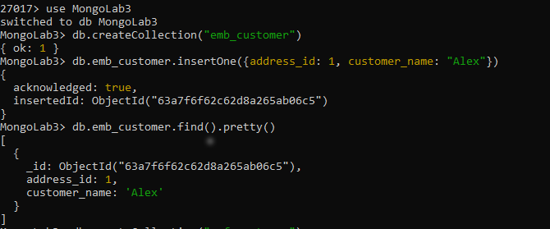

Create a new collection, which called **“ref_customer”**, and insert one document:

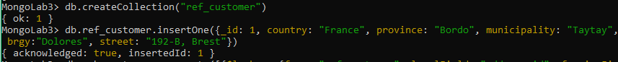

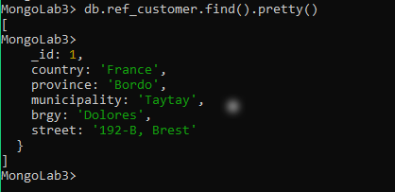

Here we have **one-to-one relationship**, and to demonstrate it I used *aggregate*:

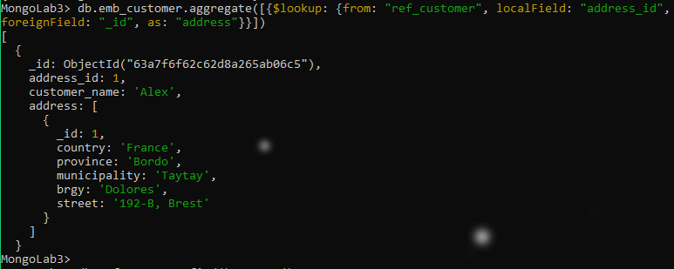

**Task 2**

Create a new collection, which called **“students”**, and insert one document:

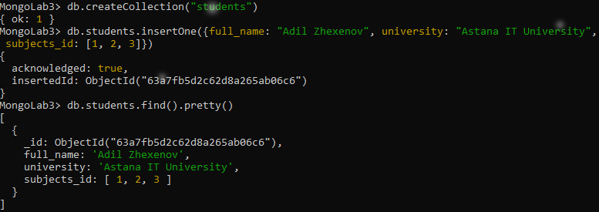

Create a new collection, which called **“subjects”**, and insert three documents:

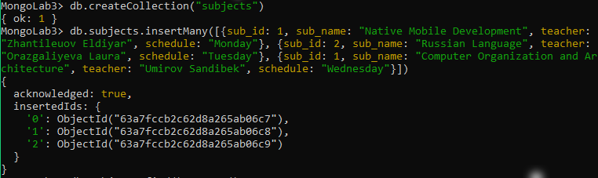

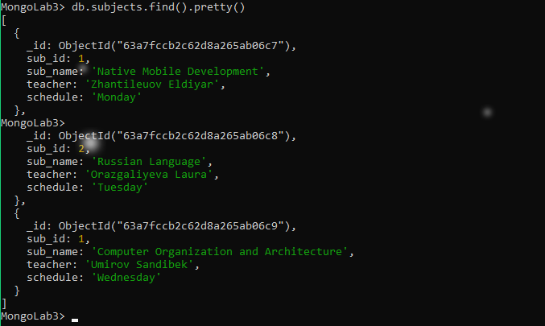

Here we have **one-to-many relationship**, and to demonstrate it I used *aggregate*:

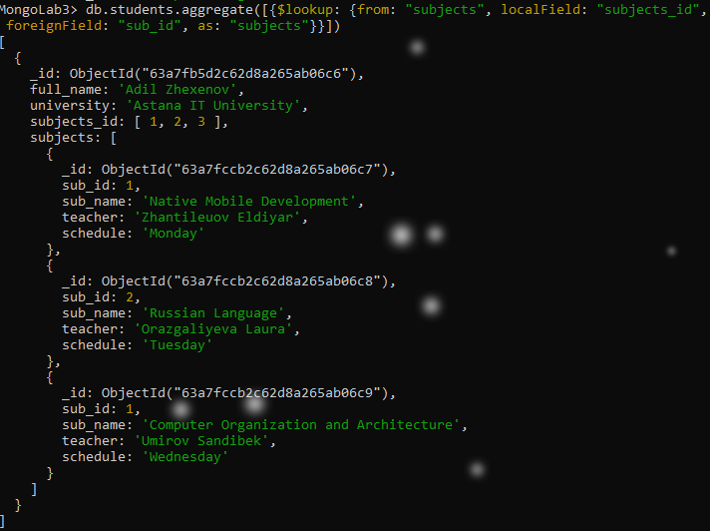

**Task 3**

